TITLES & PRICING FOR TRANSITION ABSTRACT SERIES FOR PYNELOGS

TITLE MEDIUM SIZE (WXH) PRICE

Canvas Framed- Black Floating- Wood

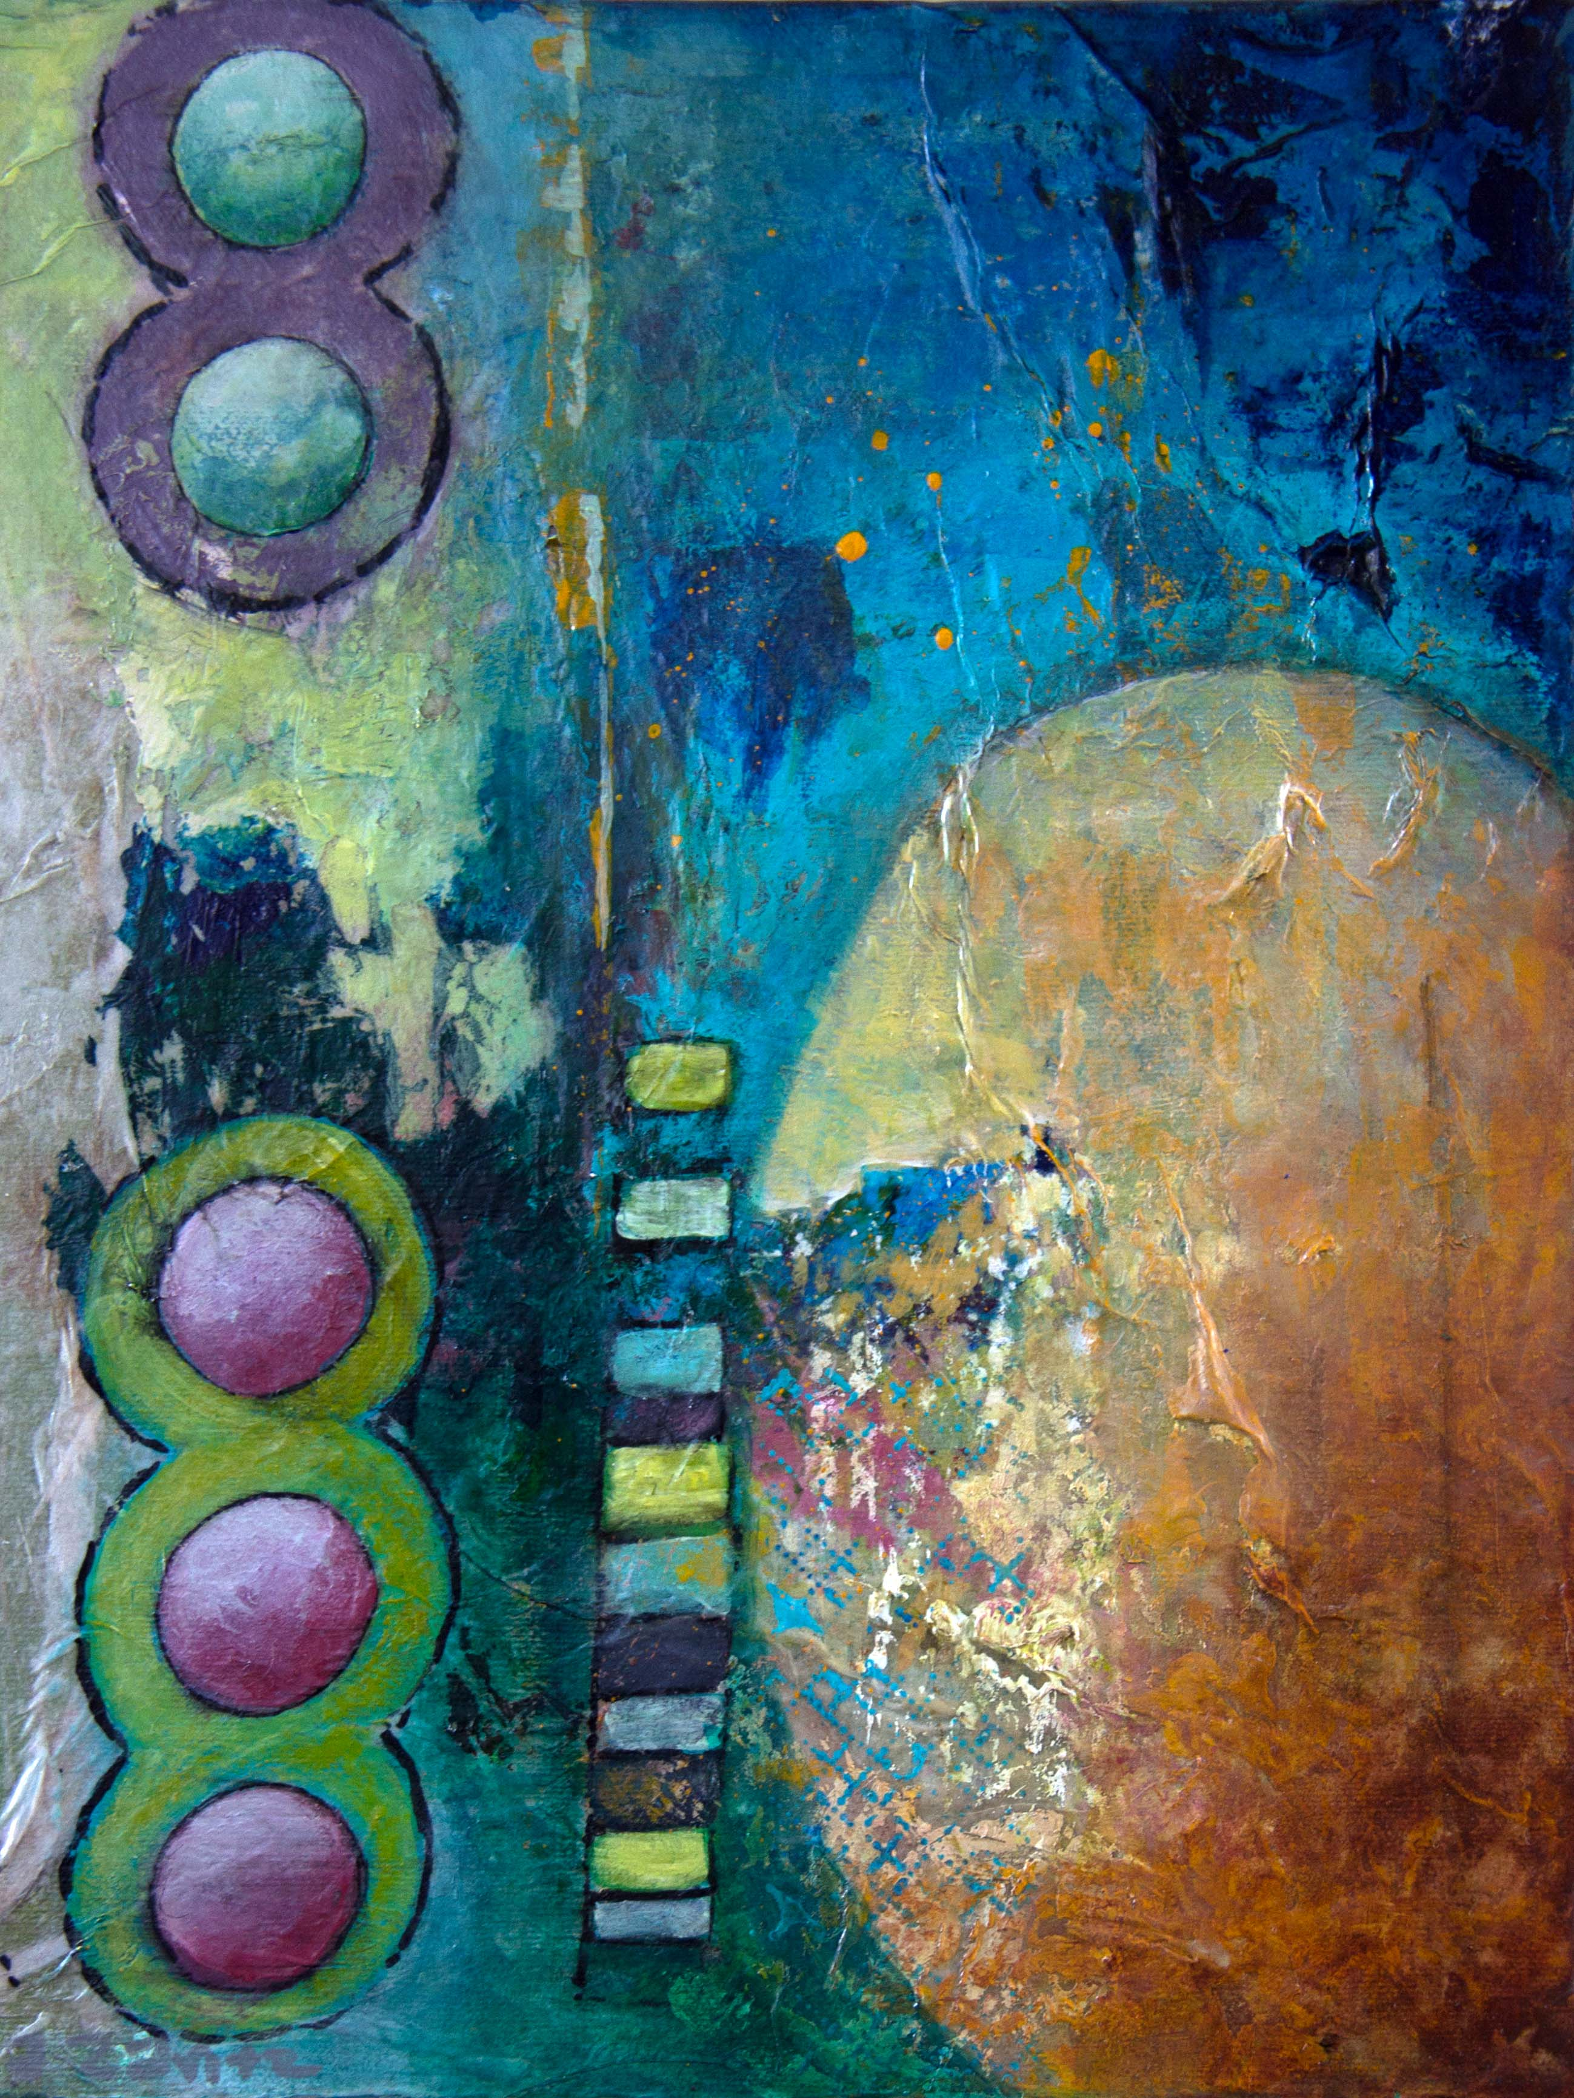
Stacking the Odds Mixed Media Acrylic 11”X14” $160
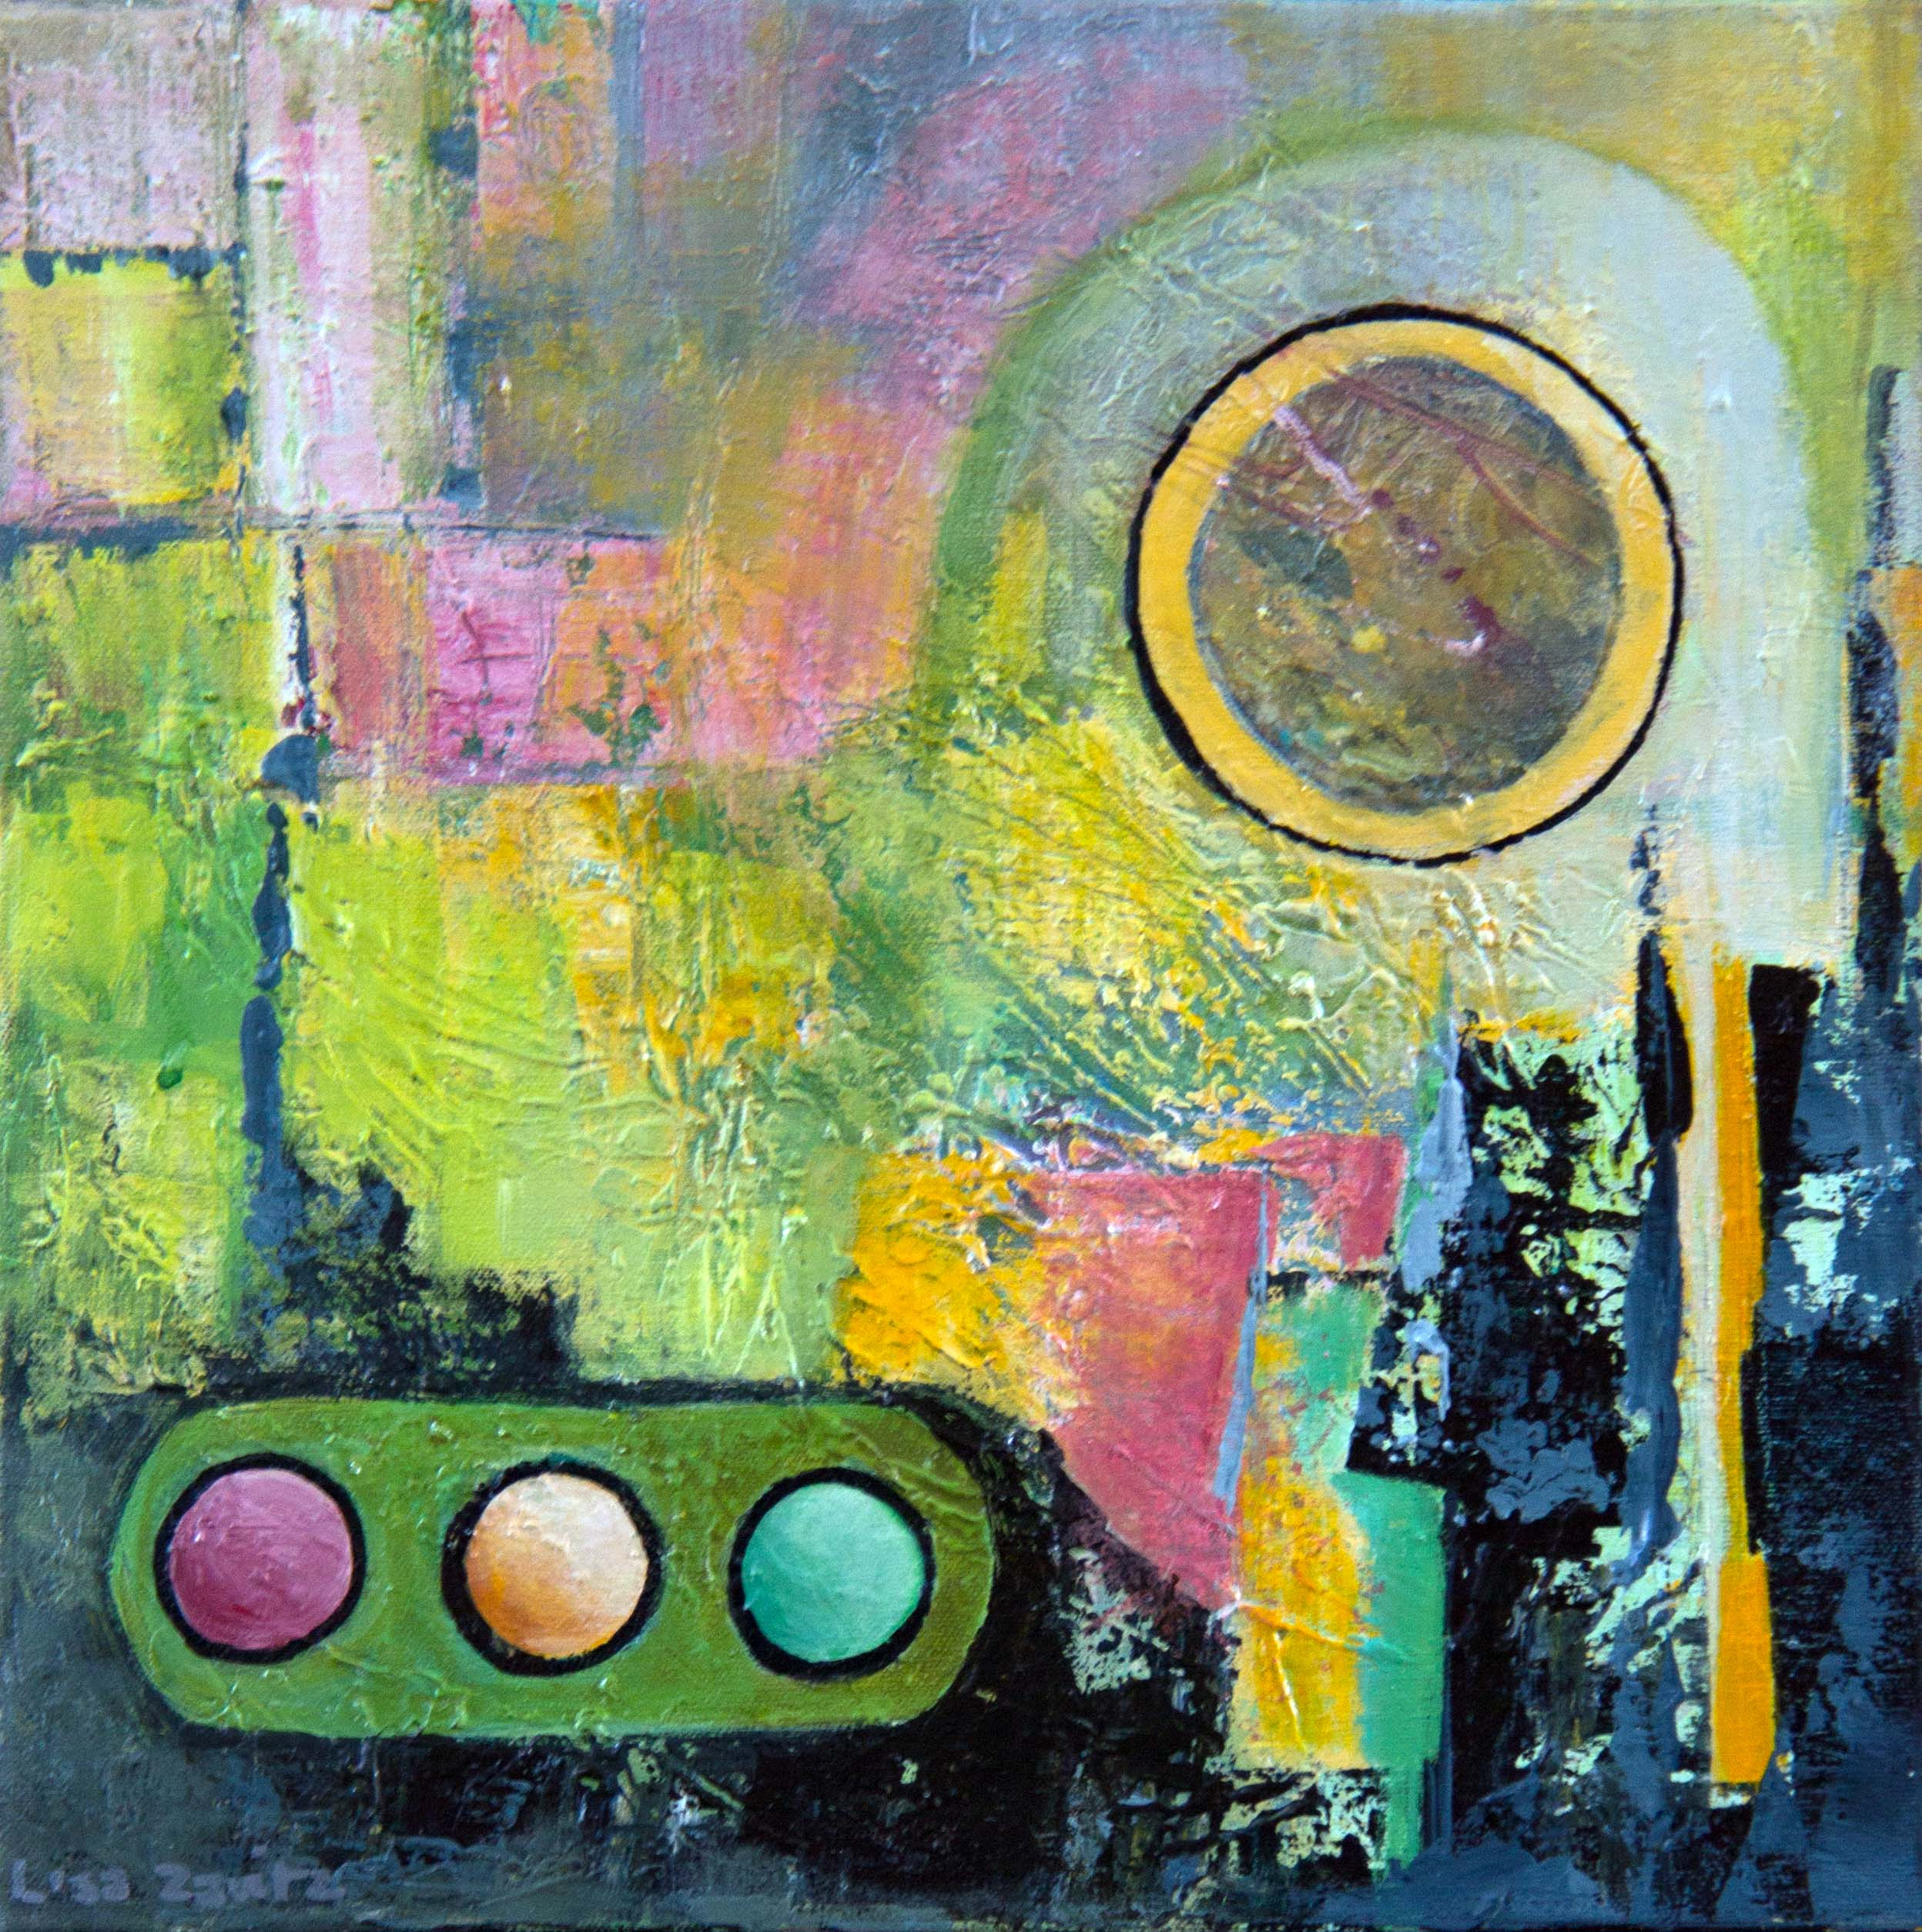
Green Means Go Mixed Media Acrylic 14”X14” $190
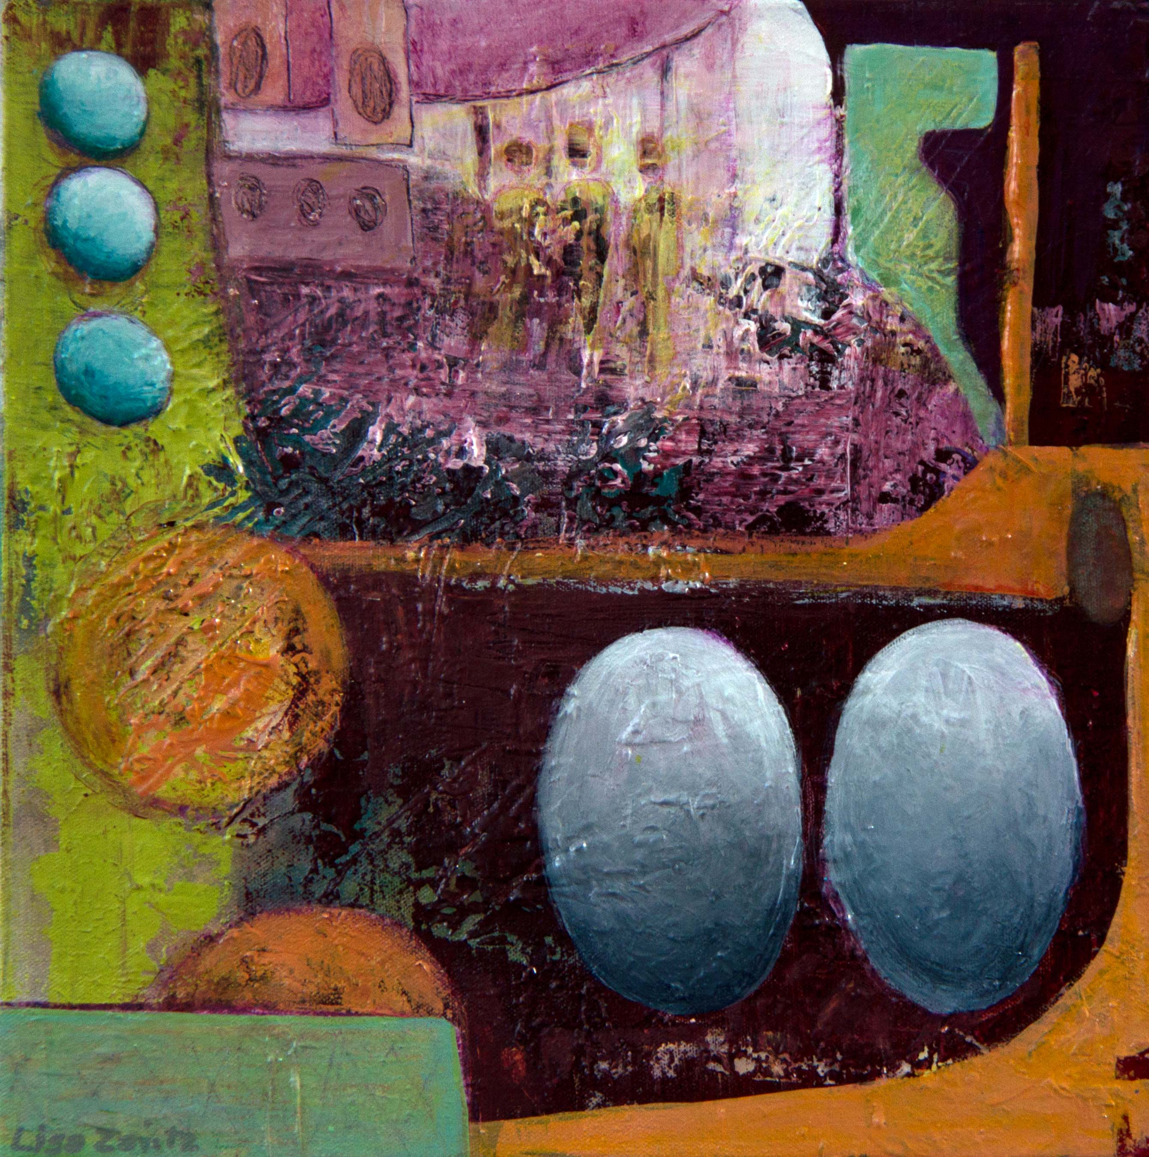
Group Identity Mixed Media Acrylic 14”X14” $190
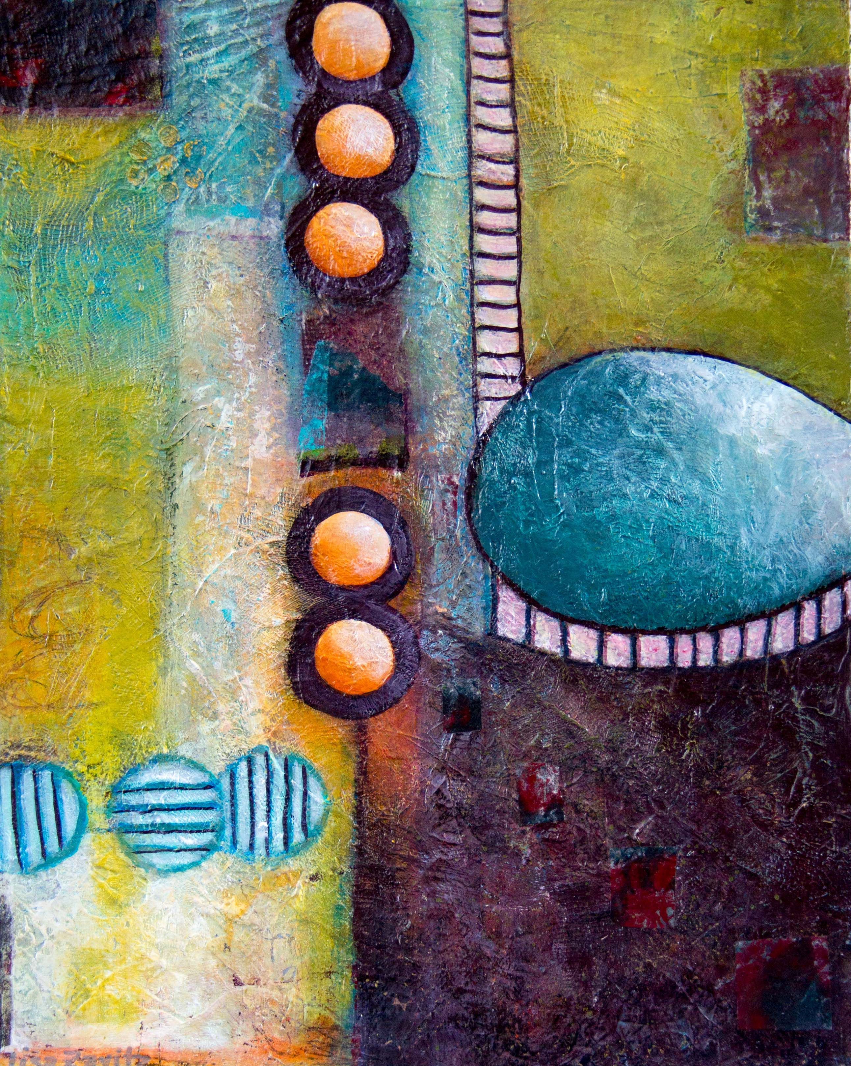
Striking a Balance Mixed Media Acrylic 16”X20” $285
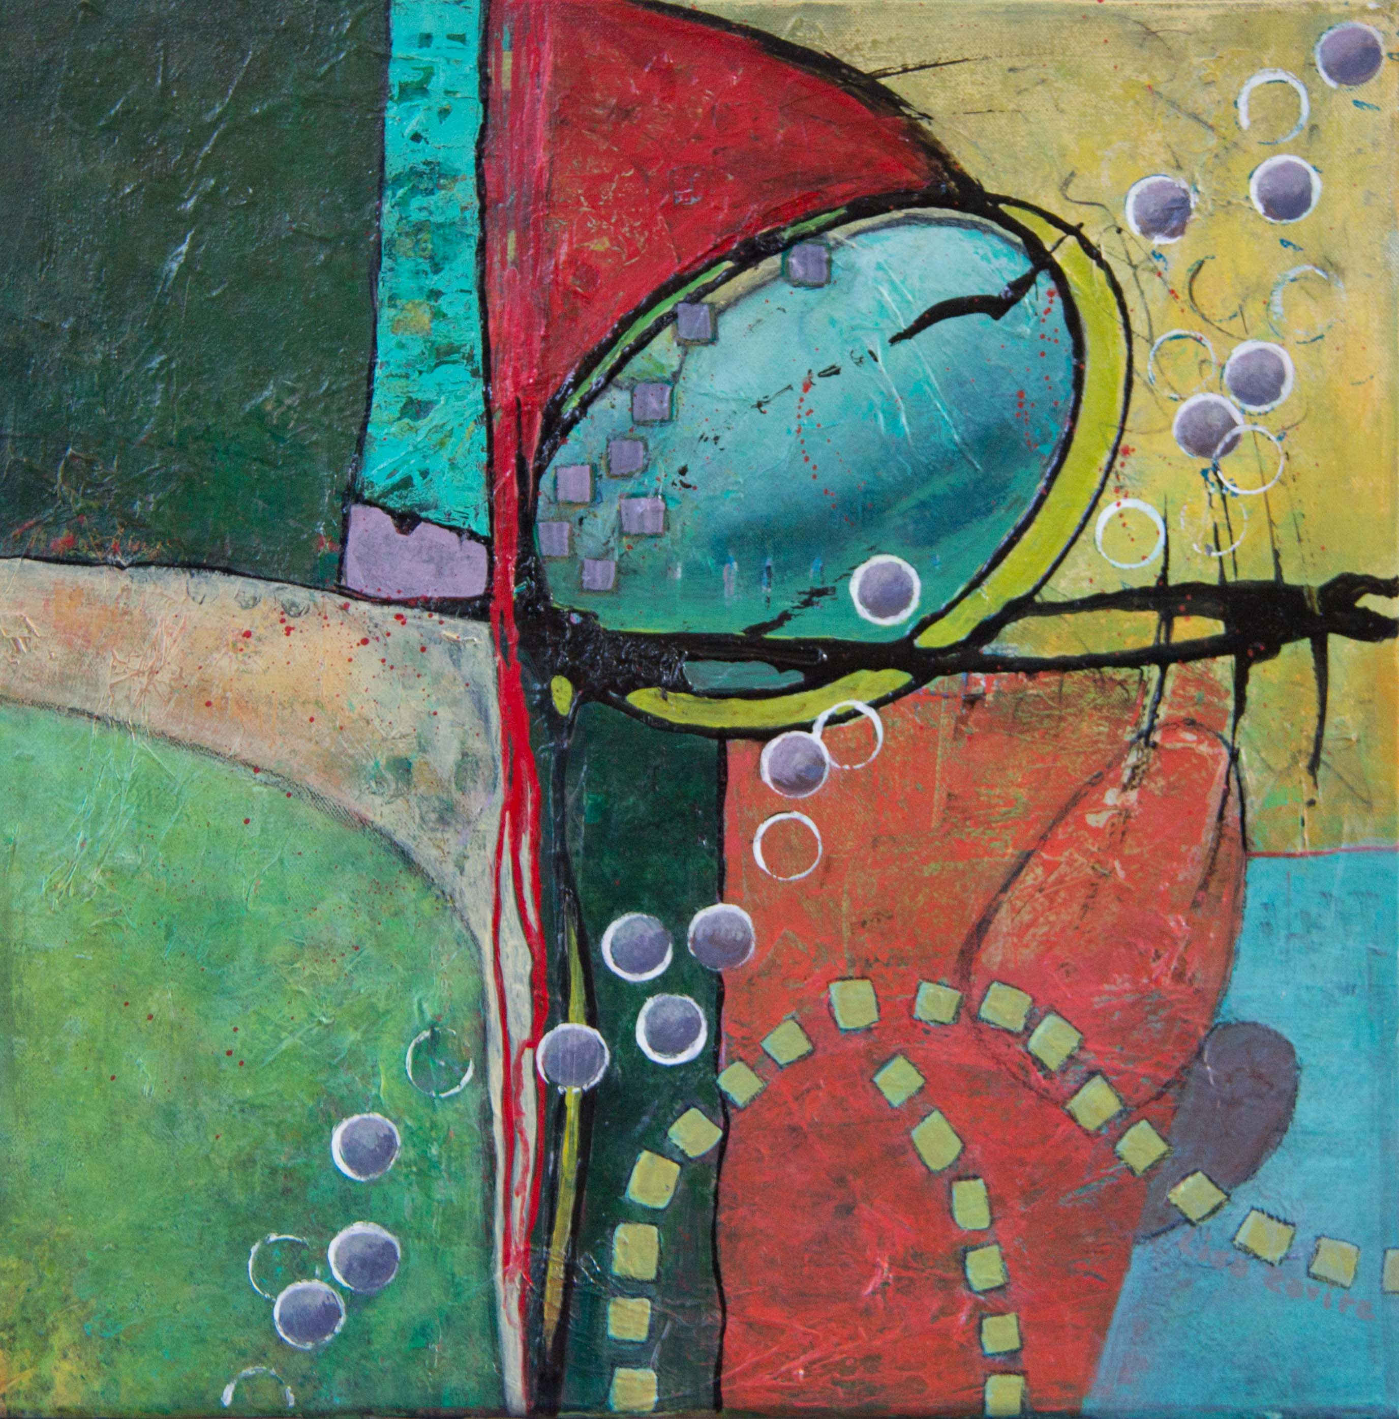
Chain Reaction Mixed Media Acrylic 20”X20” $360
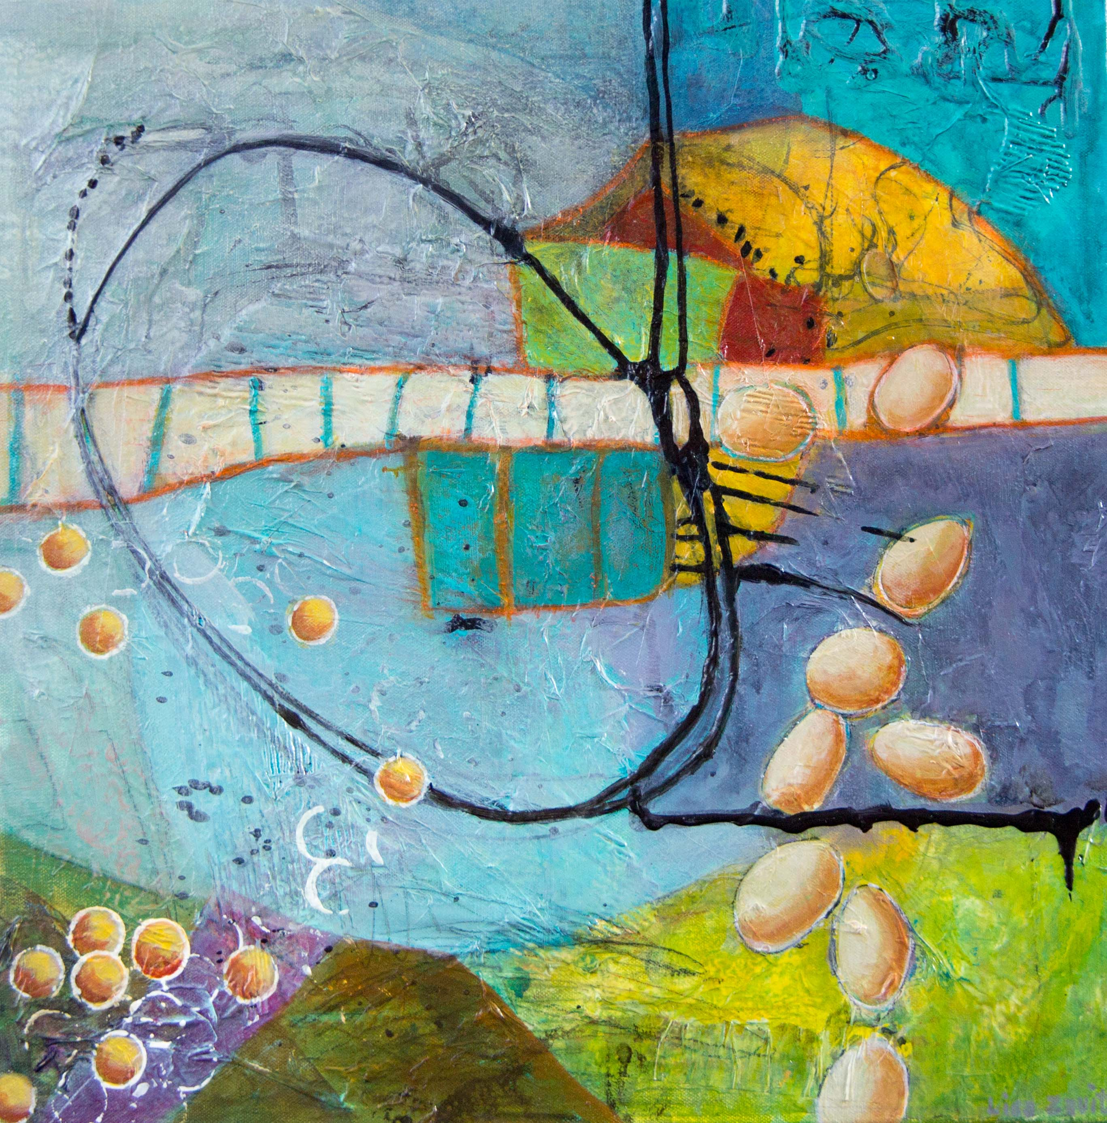
Thinking Outside the Box Mixed Media Acrylic 20”X20” $360
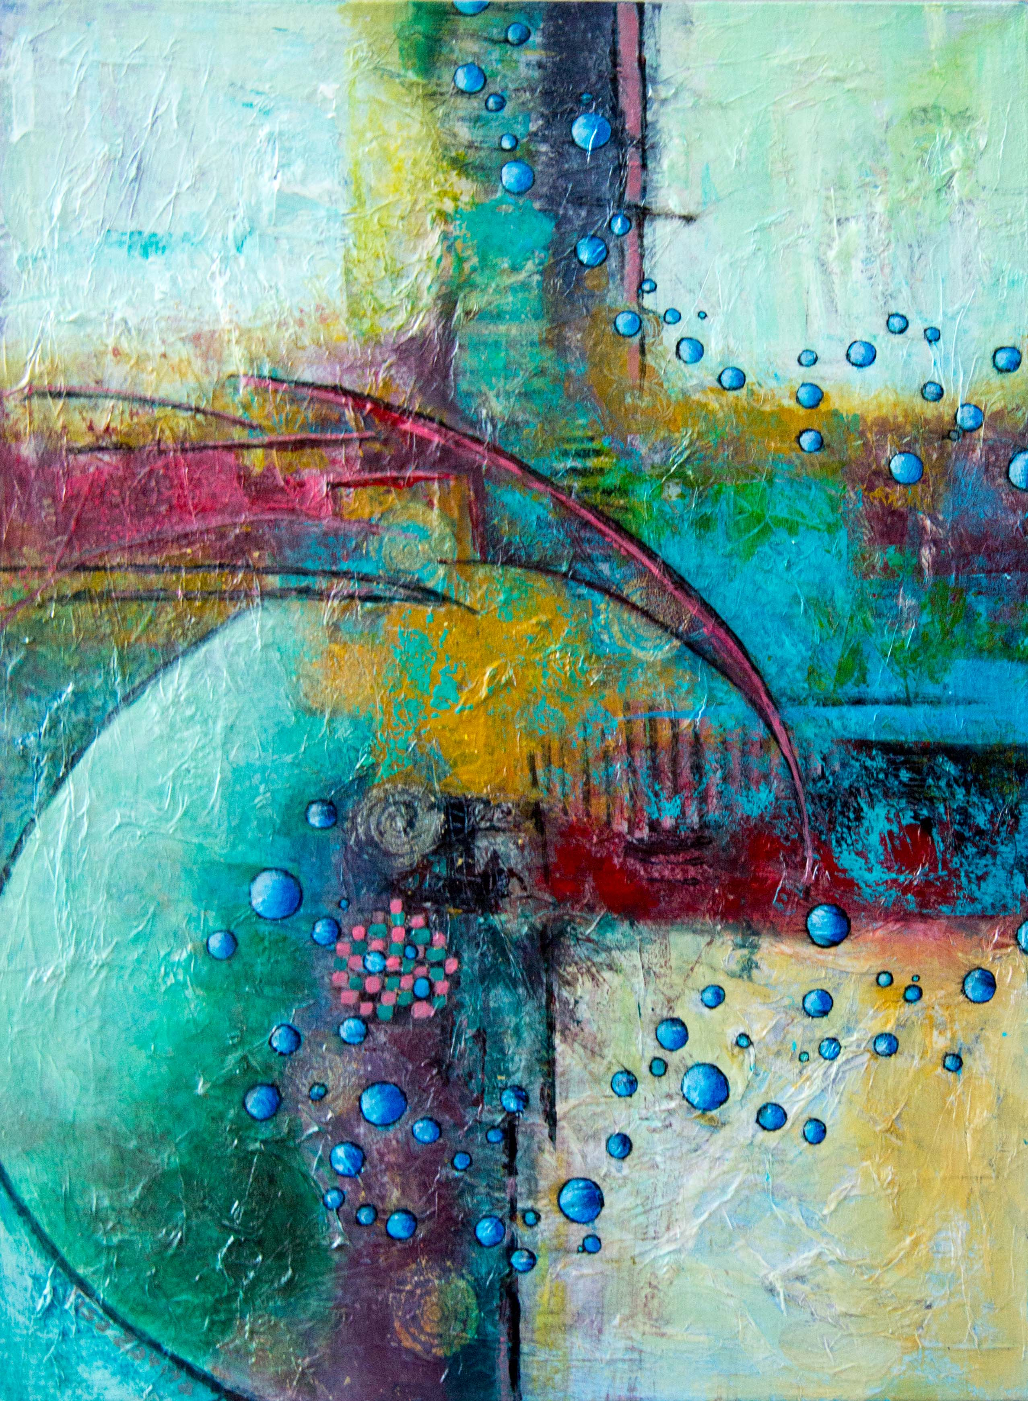
Following a Train of Thought Mixed Media Acrylic 18”X24” $390
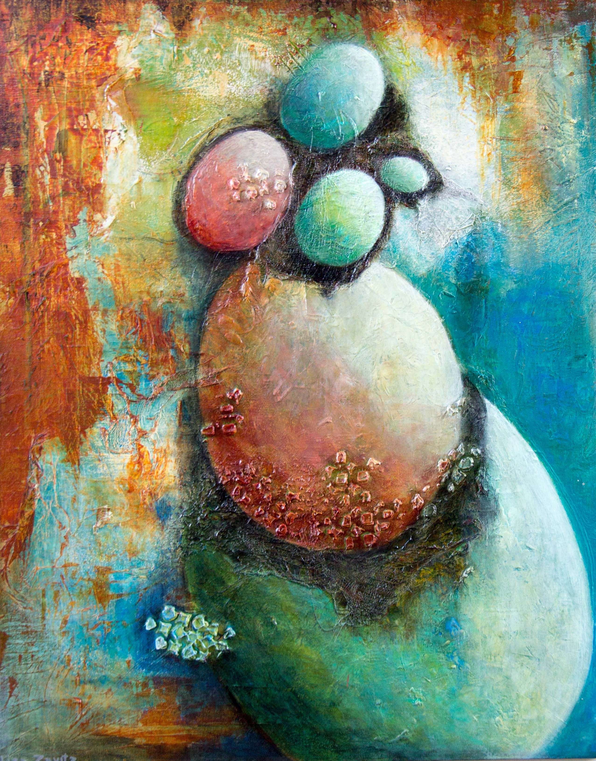
Building a Nest Egg Mixed Media Acrylic 24”X30” $650
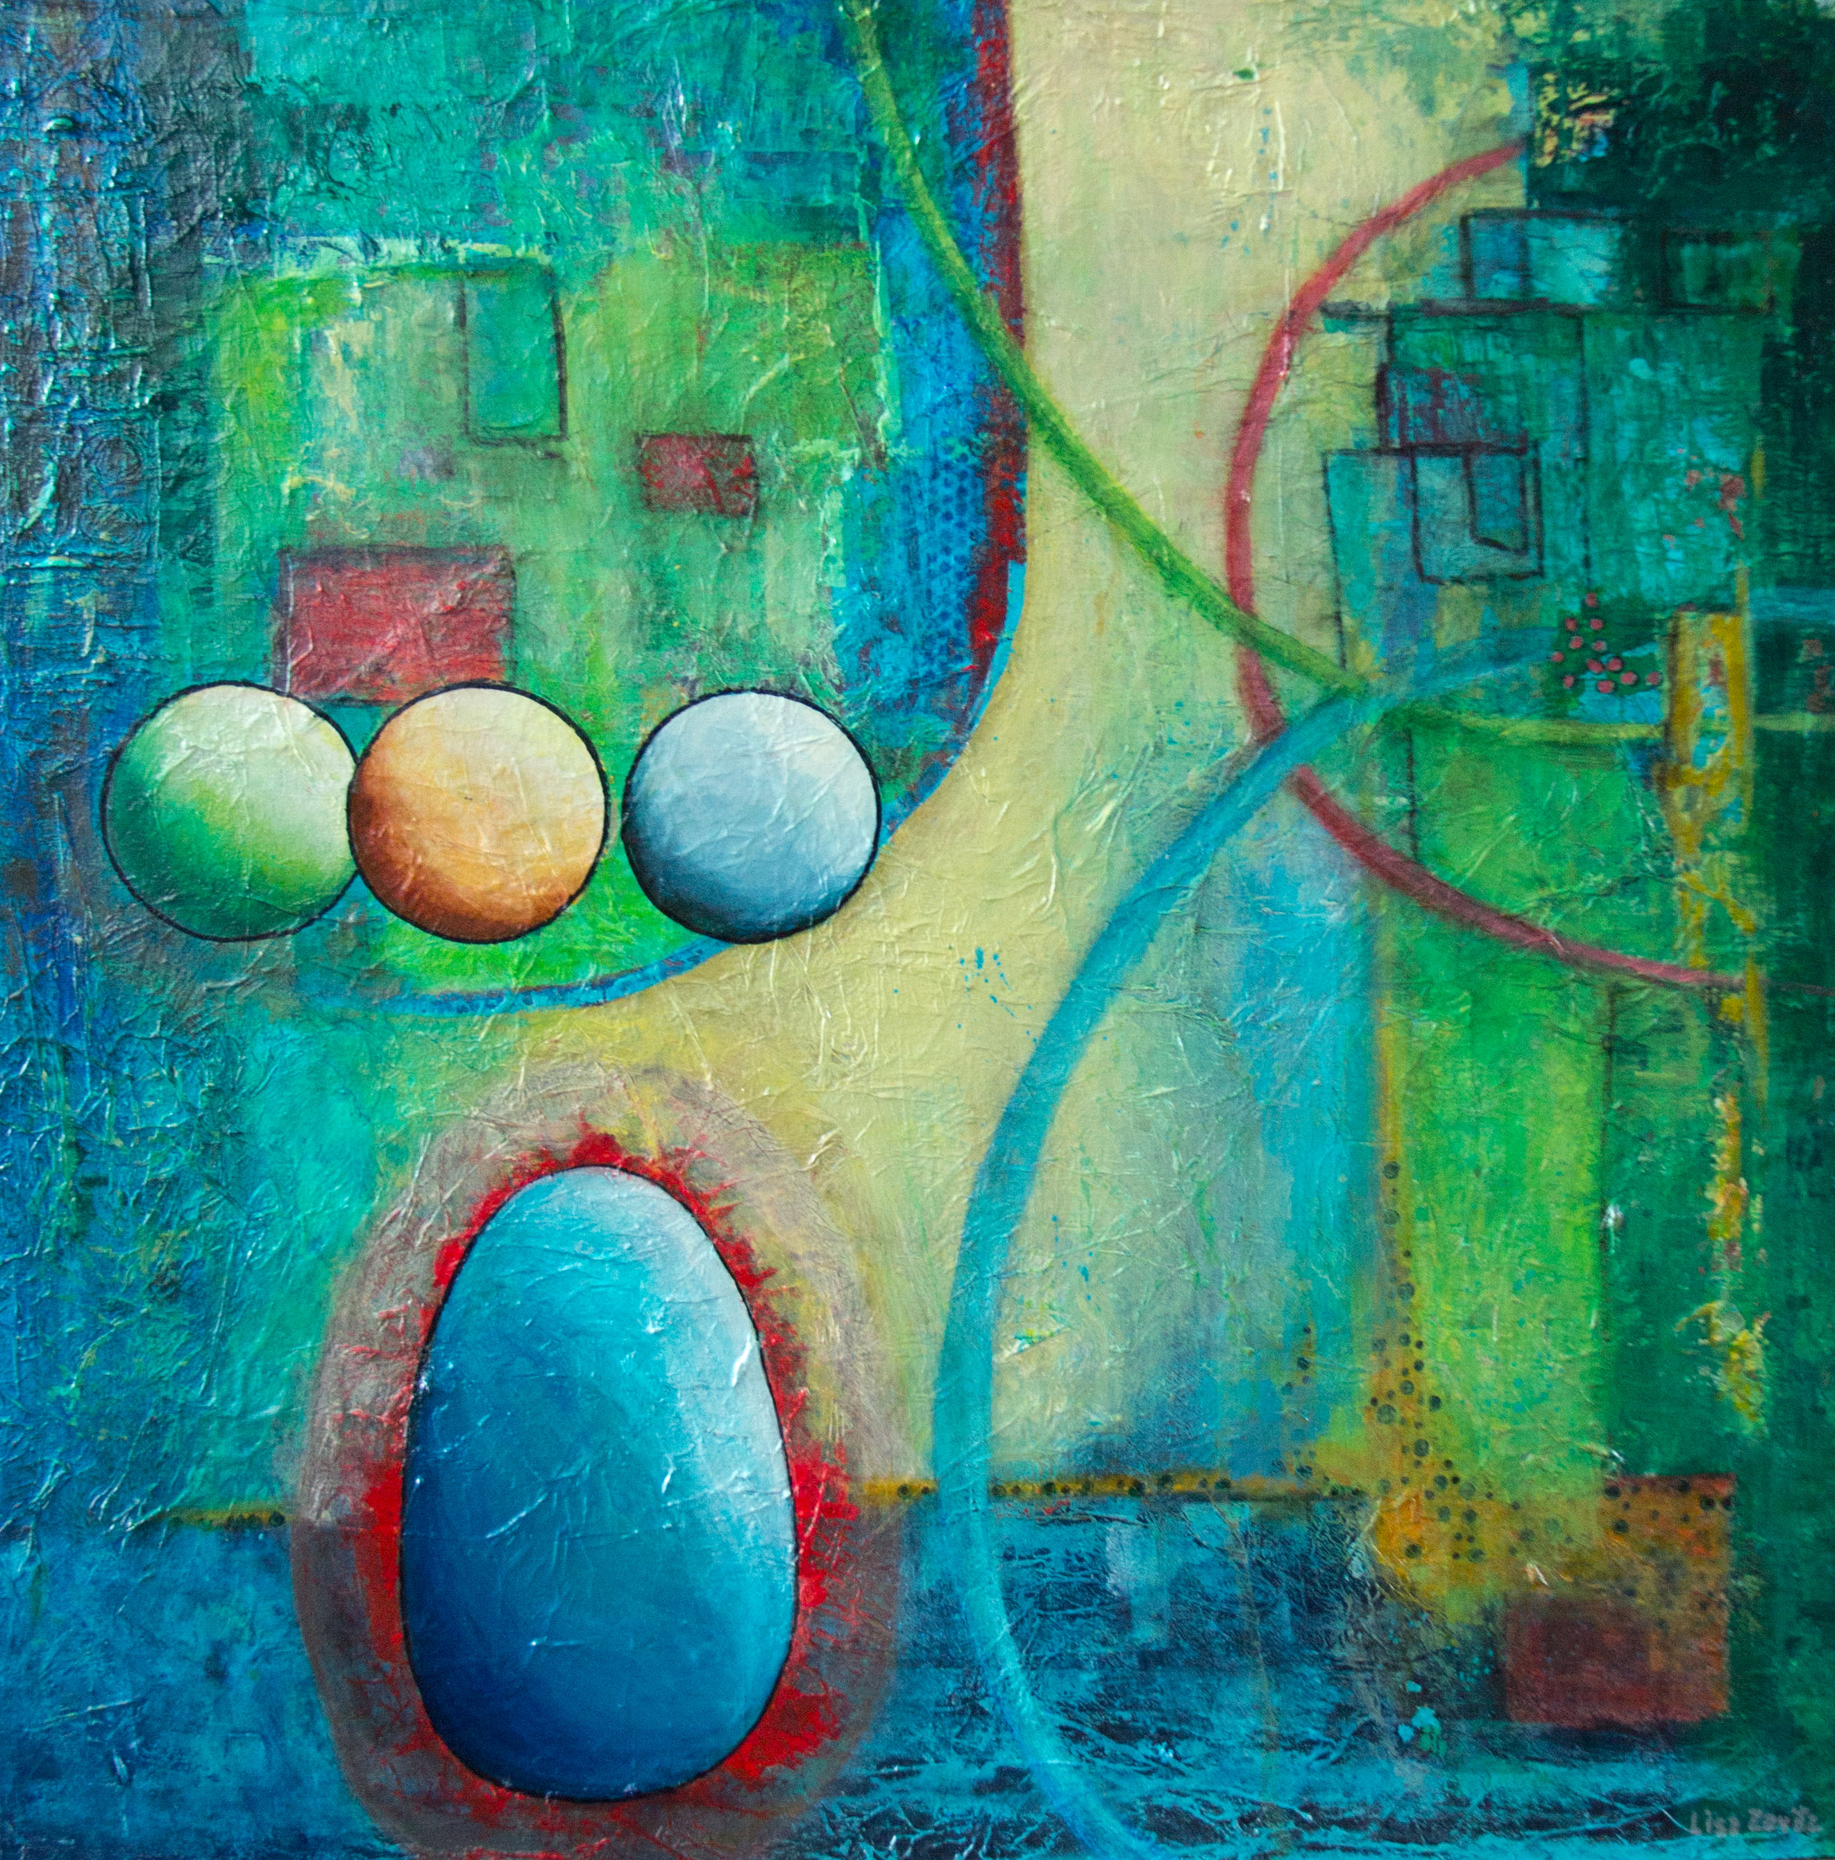
Circle of Life Mixed Media Acrylic 30”X30” $790

Canvas Unframed – Gallery Depth (1.5”)

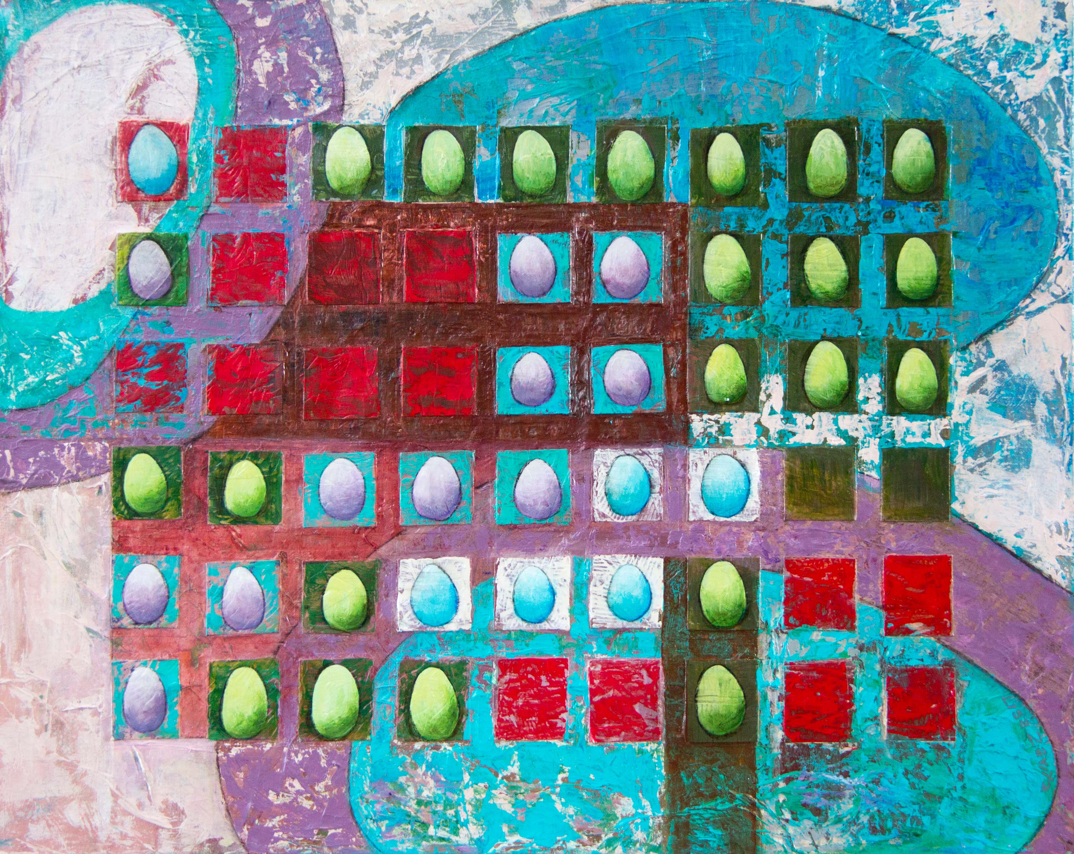
Change is the Only Constant Mixed Media Acrylic 30”X24” $650
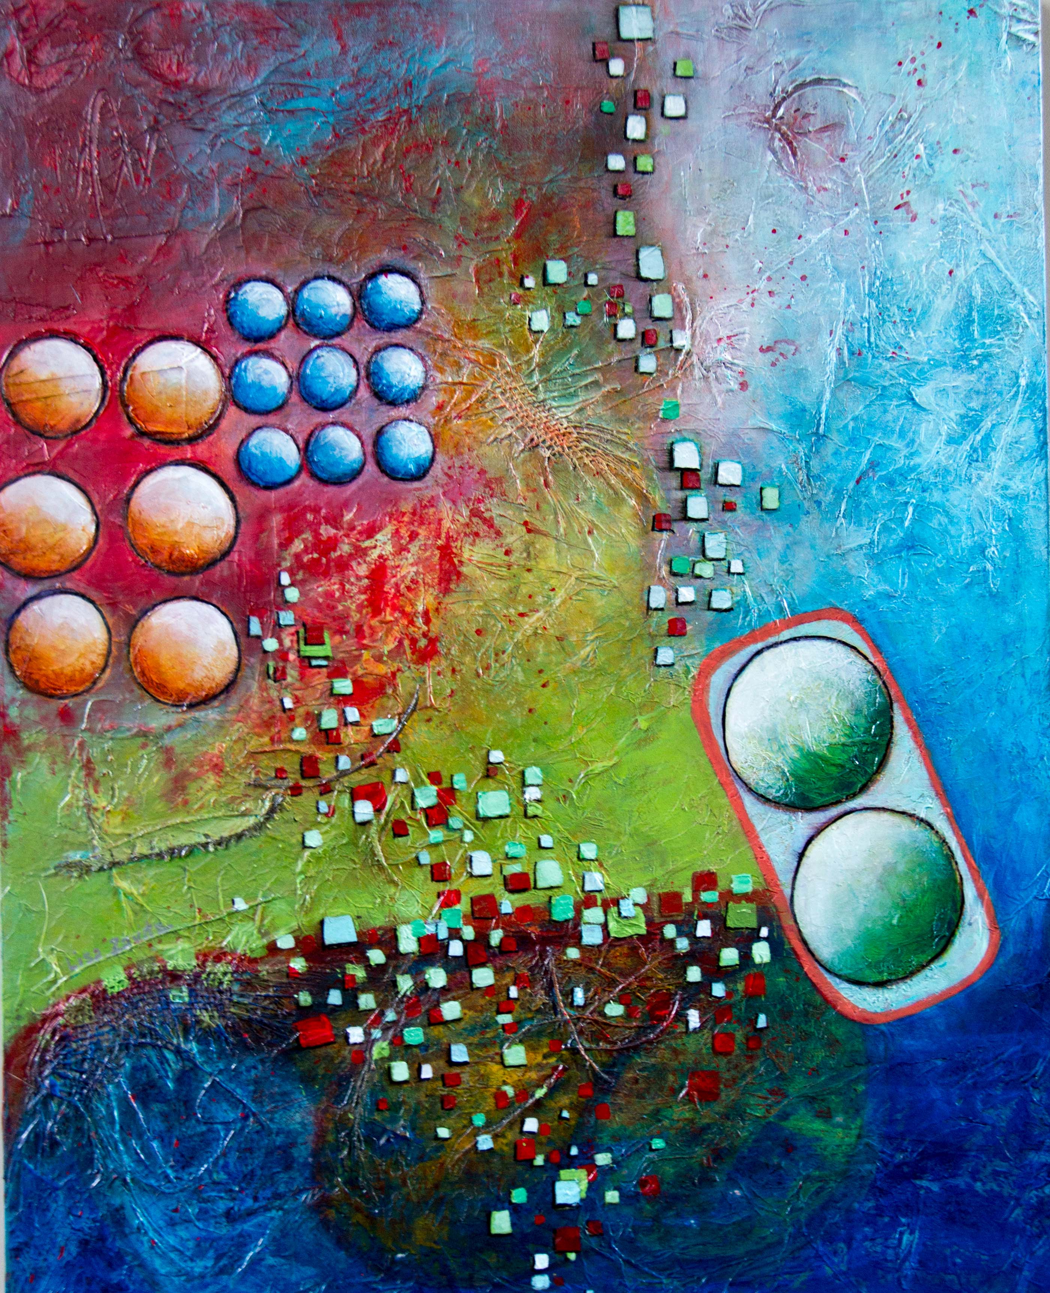
Collective Thought Mixed Media Acrylic 24”X30” $650
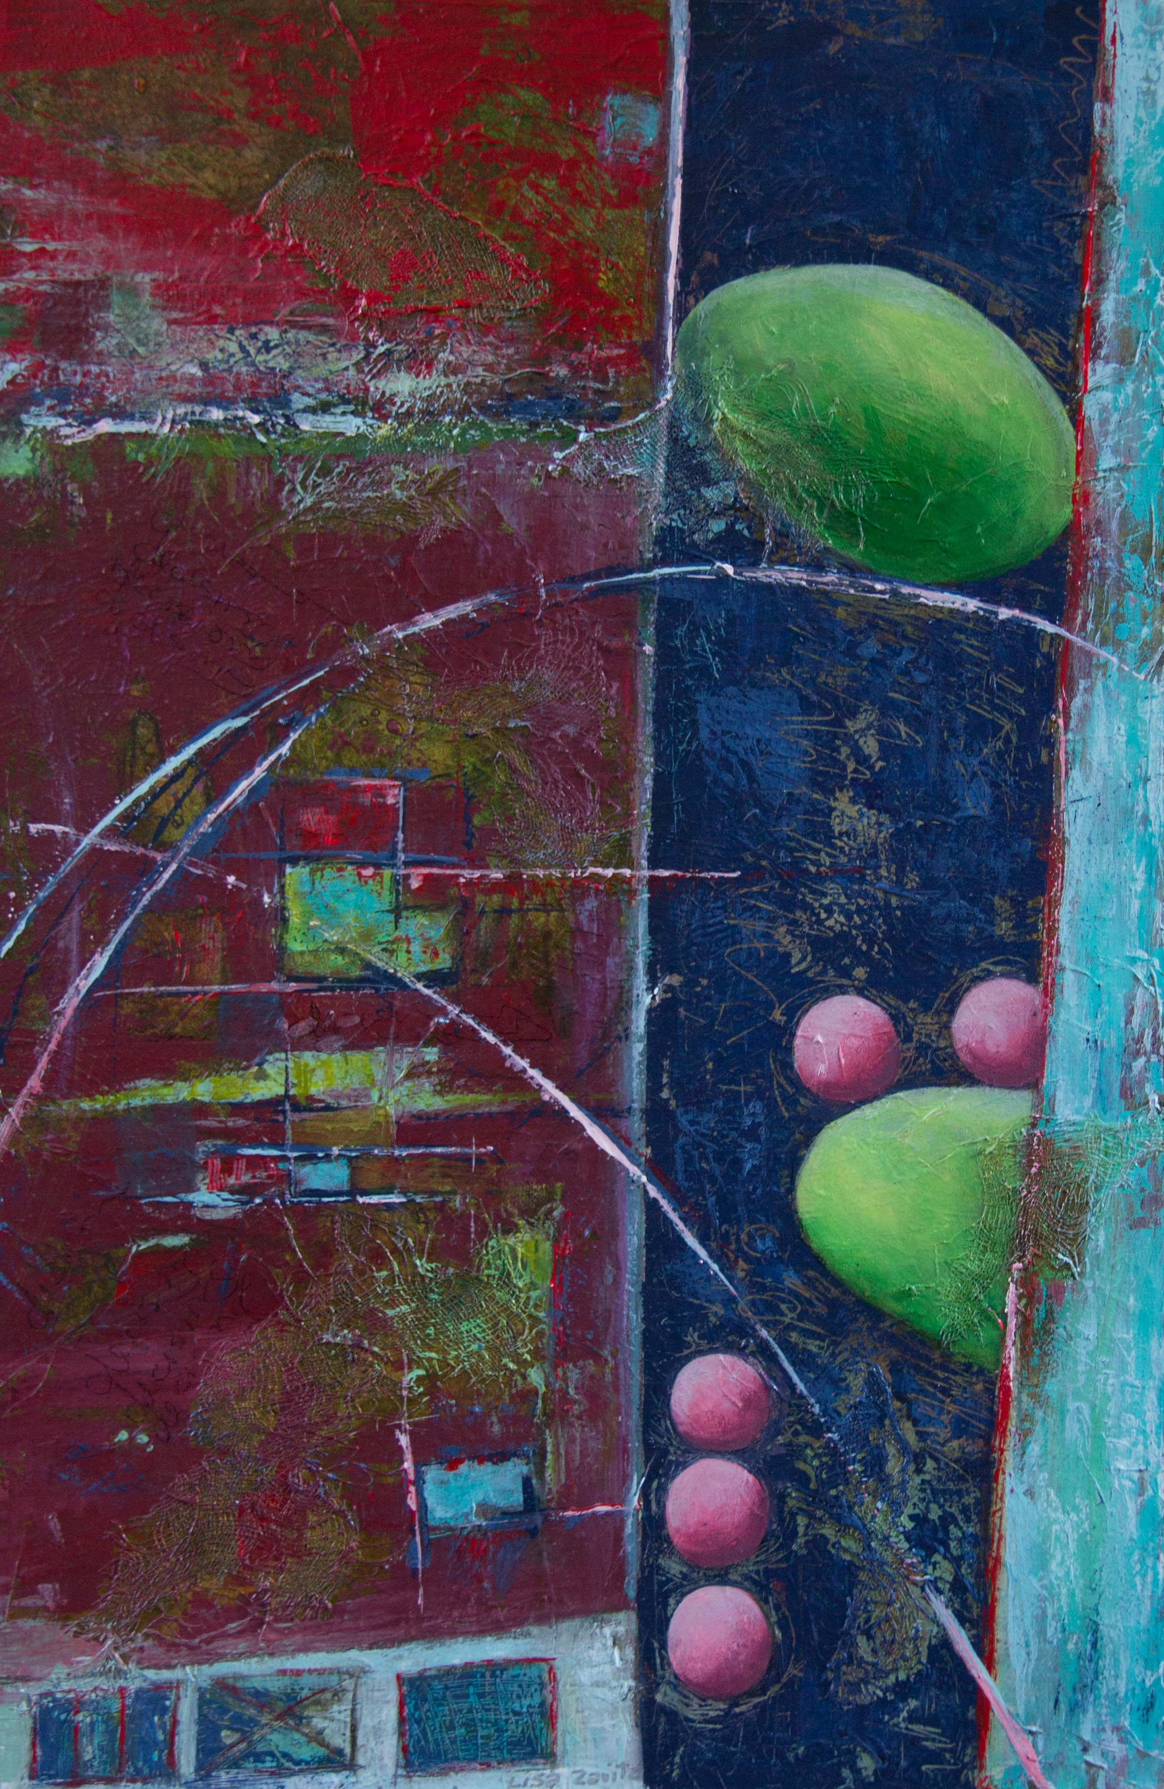
Leap of Faith Mixed Media Acrylic 24”X36” $775

